**IMPORTANT LINKS:**

**Github:** [**https://github.com/jdwdm3/SWE2016**](https://github.com/jdwdm3/SWE2016)

**Proof of Azure Setup:** jdwswe.centralus.cloudapp.azure.com

**Software Sharks (Group 8)**

**Schedule Shark**

**Requirements Analysis**

**Authors:**

Kaitlin Anderson

Jeremy Warden

Josh Lewis

Han Chen

03/27/2016

**SPRINT 2**

**Version: 0.03**

**Table of Contents**

Overview……………….……………………………………….4

The Problem……………………………………………….4

Requirements…………………………………….......................5

User Requirements………………………………………...5

System Requirements……………………………………...6

Functional…………………………………………………7

Non-Functional Requirements…………………….………8

System Design………………………………………………….9

Use Case Diagram of Whole System..………..…………...9

Activity Diagram of Schedule Interaction..……….……..10

ERD of Database…………………………………….…...11

Data Definition Language(DDL).....………………...………...12

Employee Table.…………………………………..…......12

Availability Table..………………………………..……..12

Contact Information Table.………………………..……..13

Position Table.……...……………………………..……..14

Request Off Table………..………………………..……..15

Schedule Table...…………………………………..……..15

Registration Codes Table...………………………..……..16

Data Manipulation Language(DML)………...………………..17

Employee Table.…………………………………..…......17

Availability Table..………………………………..……..18

Contact Information Table.………………………..……..18

Position Table.……...……………………………..……..20

Request Off Table………..………………………..……..21

Schedule Table...…………………………………..……..22

Registration Codes Table...………………………..……..22

User Interface……….…………………………………………23

Login/Registration……………...………………………..23

Employee Home………………………………………….26

Employee Availability…………………………………...27

Employee Contact………………………………………..28

Employee Request Off………...…………………………29

Manager Home…………………………………………..30

Manager Availability…………………………………….31

Manager Contact…………………………………………32

Manager Request Off………………………………….…33

Testing…………………………………………………………35

User Acceptance Testing...………………………..……..35

Unit Testing...………………………..………………......35

Regression Testing...…………………..…………..….….36

Integration Testing...……………….……………..….…..36

Change Log…..………………………………………….…….37

Glossary…..…………………………………………….……..39

OVERVIEW

**-- PROBLEM --**

During the last few years, multiple members of our group have experienced poor scheduling techniques used for our various places of employment. It is a rather daunting task to balance everything that pertains to each employee such as availability and requesting off in order to formulate an accurate schedule. Additionally, to add an extra headache to the scheduling manager, they also have to create multiple schedules for various positions that are held. Managers already have enough work to attend to with daily problems that occur at the workplace, so we believe we can alleviate some of that stress with the implementation of Schedule Shark!

REQUIREMENTS

**-- USER REQUIREMENTS --**

**Primary: Kaitlin Anderson**

**Secondary: Jeremy Warden**

* **Employees**
  + Server
  + Bartender
  + Busser
  + Food-Runner
  + Cashier
  + Hostess/Host
  + Supervisor
* **Managers**
  + Floor Manager
  + Branch Manager
* **Manager Requirements**
  + Edit Schedule
    - Swap shifts
    - Remove employees
    - Add employees
    - Change times of shifts
  + Generate Registration Code for New Employees
  + Accept Request Off from Employees
  + Accept Availability Changes from Employees
  + Contact All Employees
* **Employee Requirements**
  + Give Availability
    - Day of availability
    - Time of availability
  + Request Time Off
  + Edit Availability
  + Contact employees within the same job title
* **Manager and Employee Requirements**
  + Registration
  + User Login
  + View Schedule
  + General Search of Employees

**-- SYSTEM REQUIREMENTS --**

**Primary: Jeremy Warden**

**Secondary: Kaitlin Anderson**

* **Cloud Storage**
  + Azure
* **LAMP Stack (stored on azure)**
  + Linux
    - Virtual Machine is powered by Linux, creating a safe environment for us to utilize the resources necessary to run our application
  + Apache
    - Web server where we will be hosting our web application
  + MySQL Database
    - Our web based application will be database driven, using user data in order to function properly
  + Python/PHP
    - We will be communicating between our controller and our model with a server side scripting language

**-- FUNCTIONAL REQUIREMENTS --**

**Primary: Han Chen**

**Secondary: Josh Lewis**

* **User Login**
  + On correct input, advances user to site.
  + On incorrect input, allows user to try again or change password.
* **Give Availability**
  + Store Employees availability
  + Use information for generating Schedule
  + Edit availability
* **Request Time off**
  + Send request off dates to manager in order for approval
  + Store date on approval
  + Use information for generating schedule
* **View Schedule**
  + Each type of employee will have ability to view the corresponding schedule
* **Edit Schedule**
  + Managers should be able to make changes to the schedule
* **Contact Other Employees**
  + Managers should be able to mass e-mail employees.
  + Employees should be able to contact similar employees, as well as their manager.
* **Adding New Employees**
  + Generate random code for employee to enter and gain access to system

**-- NON-FUNCTIONAL REQUIREMENTS --**

**Primary: Josh Lewis**

**Secondary: Han Chen**

* **Stability**
  + The program should be stable; it should have a one percent failure rate.
* **Efficiency**
  + The program should be fast and efficient, responding in under a minute to queries and requests.
* **Recoverability**
  + The program should recover gracefully from incorrect inputs and from system outages.
* **Database**
  + Database should be able to handle large amount of data and simultaneous requests.
* **Security**
  + System should be secure, not just anybody can register for an account in the system, and employees must register with an access code generated by a manager.
* **Platforms**
  + Should work on multiple web platforms including, IOS and Android web browsers.

SYSTEM DESIGN

**-- USE CASE DIAGRAM OF WHOLE SYSTEM --**

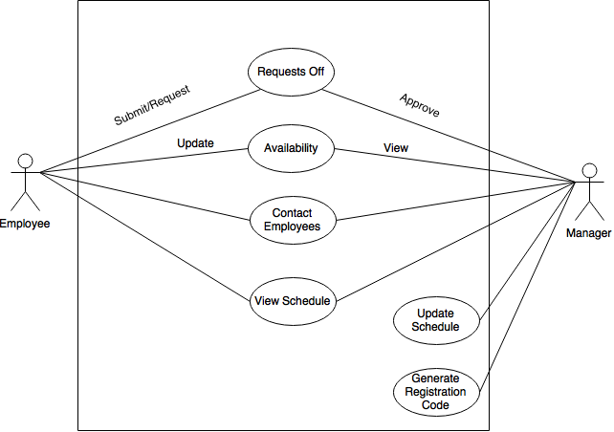

**-- ACTIVITY DIAGRAM OF SCHEDULE INTERACTION --**

Macintosh HD:Users:kaitlinanderson:Library:Containers:com.apple.mail:Data:Library:Mail Downloads:74DE98FE-871F-4794-A042-D62B1234E862:Activity_DiagramV2.png

**-- ERD OF DATABASE --**

Macintosh HD:Users:kaitlinanderson:Desktop:SWE2016:AllDocuments:Group8ERD.pdf

DATA DEFINITION LANGUAGE (DDL)

--**EMPLOYEE --**

CREATE TABLE Employee

(

employee\_ID int,

first\_name varchar(25),

last\_name varchar(25),

birthday Date,

password varchar(25),

PRIMARY KEY (employee\_ID)

);

INSERT INTO Employee (employee\_ID, first\_name, last\_name, birthday, password)

VALUES (0,'Jeremy','Warden','1996-11-30'. ‘Hello123’);

INSERT INTO Employee (employee\_ID, first\_name, last\_name, birthday, password)

VALUES (1,'Joe','Peshi','1948-06-23', ‘Hello123’);

INSERT INTO Employee (employee\_ID, first\_name, last\_name, birthday, password)

VALUES (2,'Han','Chen','1995-02-14', ‘Hello123’);

INSERT INTO Employee (employee\_ID, first\_name, last\_name, birthday, password)

VALUES (3,'Kaitlyn','Anderson','1994-04-19', ‘Hello123’);

INSERT INTO Employee (employee\_ID, first\_name, last\_name, birthday, password)

VALUES (4,'Josh','Lewis','1994-02-21', ‘Hello123’);

INSERT INTO Employee (employee\_ID, first\_name, last\_name, birthday, password)

VALUES (5,'Donkey','Kong','1963-12-24', ‘Hello123’);

INSERT INTO Employee (employee\_ID, first\_name, last\_name, birthday, password)

VALUES (6,'Remilia','Scarlet','1509-06-13', ‘Hello123’);

INSERT INTO Employee (employee\_ID, first\_name, last\_name, birthday, password)

VALUES (7,'Bruce','Wayne','1971-01-29', ‘Hello123’);

INSERT INTO Employee (employee\_ID, first\_name, last\_name, birthday, password)

VALUES (8,'Deadpool','Awesomeguy','1948-09-19', ‘Hello123’);

--**CONTACT INFORMATION--**

CREATE TABLE Contact\_Information

(

employee\_ID int,

phone\_number varchar(10),

email varchar(50),

zip varchar(5),

region varchar (2),

PRIMARY KEY (employee\_ID),

FOREIGN KEY (employee\_ID) REFERENCES Employee(employee\_ID)

);

INSERT INTO Contact\_Information (employee\_ID, phone\_number, email, zip, region)

VALUES (0,'5738765309','jeremy@whatever.com', '65202', 'MO');

INSERT INTO Contact\_Information (employee\_ID, phone\_number, email, zip, region)

VALUES (1,'5738490998','joe.peshi@ReallyFamous.com', '64908', 'IL');

INSERT INTO Contact\_Information (employee\_ID, phone\_number, email, zip, region)

VALUES (2,'4897684430','han.chen@whatevers.com', '65202', 'MO');

INSERT INTO Contact\_Information (employee\_ID, phone\_number, email, zip, region)

VALUES (3,'5734443344','Kaitlin@something.com', '65202', 'MO');

INSERT INTO Contact\_Information (employee\_ID, phone\_number, email, zip, region)

VALUES (4,'5737890020','josh@whatever.com', '65203', 'MO');

INSERT INTO Contact\_Information (employee\_ID, phone\_number, email, zip, region)

VALUES (5,'1113987654','KRoolDroolz@bananas.com', '12345', 'AR');

INSERT INTO Contact\_Information (employee\_ID, phone\_number, email, zip, region)

VALUES (6,'6669874636','remilia.scarlet@gmail.com', '48765', 'KS');

INSERT INTO Contact\_Information (employee\_ID, phone\_number, email, zip, region)

VALUES (7,'4389207839','gotham@batcave.com', '98766', 'NY');

INSERT INTO Contact\_Information (employee\_ID, phone\_number, email, zip, region)

VALUES (8,'2874392938','deadpool@thebestemail.best', '48732', 'LA');

--**POSITION--**

CREATE TABLE Position

(

employee\_ID int,

position\_IDs varchar(10),

PRIMARY KEY (employee\_ID),

FOREIGN KEY (employee\_ID) REFERENCES Employee(employee\_ID)

);

INSERT INTO Position (employee\_ID, position\_IDs) VALUES (0,'1');

INSERT INTO Position (employee\_ID, position\_IDs) VALUES (1,'2');

INSERT INTO Position (employee\_ID, position\_IDs) VALUES (2,'3');

INSERT INTO Position (employee\_ID, position\_IDs) VALUES (3,'4');

INSERT INTO Position (employee\_ID, position\_IDs) VALUES (4,'2');

INSERT INTO Position (employee\_ID, position\_IDs) VALUES (5,'5');

INSERT INTO Position (employee\_ID, position\_IDs) VALUES (6,'5');

INSERT INTO Position (employee\_ID, position\_IDs) VALUES (7,'3');

INSERT INTO Position (employee\_ID, position\_IDs) VALUES (8,'4');

--**AVAILABILITY--**

CREATE TABLE Availability

(

employee\_ID int,

days varchar(10),

times time,

PRIMARY KEY (employee\_ID),

FOREIGN KEY (employee\_ID) REFERENCES Employee(employee\_ID)

);

INSERT INTO Availability (employee\_ID,days,times) VALUES

(0,'MTWTHFS','08:00:00');

INSERT INTO Availability (employee\_ID,days,times) VALUES

(1,'TWTHFS','12:00:00');

INSERT INTO Availability (employee\_ID,days,times) VALUES

(2,'MTWTHS','10:00:00');

INSERT INTO Availability (employee\_ID,days,times) VALUES

(3,'MTWTHFS','06:00:00');

INSERT INTO Availability (employee\_ID,days,times) VALUES

(4,'MTWFS','09:45:00');

INSERT INTO Availability (employee\_ID,days,times) VALUES

(5,'MTWTHFS','04:00:00');

INSERT INTO Availability (employee\_ID,days,times) VALUES

(6,'MTWTHFS','14:00:00');

INSERT INTO Availability (employee\_ID,days,times) VALUES

(7,'MTWTHF','11:00:00');

INSERT INTO Availability (employee\_ID,days,times) VALUES

(8,'MTTHFS','10:30:00');

--**REQUEST OFF--**

CREATE TABLE Request\_Off

(

employee\_ID int,

description varchar(100),

startDate Date,

endDate Date,

PRIMARY KEY (employee\_ID),

FOREIGN KEY (employee\_ID) REFERENCES Employee(employee\_ID)

);

INSERT INTO Request\_Off (employee\_ID,description,startDate,endDate) VALUES

(6,'Bored, need a break.','2016-06-19','2016-07-31');

INSERT INTO Request\_Off (employee\_ID,description,startDate,endDate) VALUES

(3,'Visiting uncle in Zimbabwae.','2016-08-10','2016-08-21');

INSERT INTO Request\_Off (employee\_ID,description,startDate,endDate) VALUES

(2,'Going to the moon for a short time.','2016-06-19','2016-06-24');

INSERT INTO Request\_Off (employee\_ID,description,startDate,endDate) VALUES

(7,'The Joker got out of prison again.','2016-10-19','2016-10-22');

INSERT INTO Request\_Off (employee\_ID,description,startDate,endDate) VALUES

(4,'Visiting uncle in Zimbabwae.','2016-12-19','2016-12-20');

--**SCHEDULE--**

CREATE TABLE Schedule

(

employee\_ID int,

days varchar(10),

times time,

PRIMARY KEY (employee\_ID),

FOREIGN KEY (employee\_ID) REFERENCES Employee(employee\_ID)

);

INSERT INTO Schedule (employee\_ID,days,times) VALUES (0,'MTWTHF','09:00:00');

INSERT INTO Schedule (employee\_ID,days,times) VALUES (1,'TWTHFS','09:00:00');

INSERT INTO Schedule (employee\_ID,days,times) VALUES (2,'MTWTHS','11:00:00');

INSERT INTO Schedule (employee\_ID,days,times) VALUES (3,'MTWTHF','10:00:00');

INSERT INTO Schedule (employee\_ID,days,times) VALUES (4,'MTWFS','09:30:00');

INSERT INTO Schedule (employee\_ID,days,times) VALUES (5,'MTWTHS','09:00:00');

INSERT INTO Schedule (employee\_ID,days,times) VALUES (6,'MTWTHF','14:00:00');

INSERT INTO Schedule (employee\_ID,days,times) VALUES (7,'MTWTHF','11:00:00');

INSERT INTO Schedule (employee\_ID,days,times) VALUES (8,'MTTHF','11:00:00');

--**REGISTRATION CODES--**

CREATE TABLE Registration\_Codes

(

code int,

PRIMARY KEY(code)

);

INSERT INTO Registration\_Codes(code) VALUES ($code);

DATA MANIPULATION LANGUAGE(DML)

**-- EMPLOYEE --**

INSERT INTO Employee (employee\_ID, first\_name, last\_name, birthday, password) VALUES ($id, $FirstName, $LastName, $Birthdate, $Password);

SELECT \* FROM Employee;

--Displays all employees

SELECT first\_name , last\_name FROM Employee WHERE birthday <= DATE\_SUB(curdate(),INTERVAL 21 YEAR);

--Returns all employees who are 21 or older

SELECT first\_name,last\_name FROM Employee WHERE employee\_ID = $id;

--Displays an employee

DELETE FROM Employee WHERE employee\_ID = $id;

--Deletes an employee based on id

SELECT Employee.first\_name AS "First Name", Employee.last\_name AS "Last Name", Request\_Off.description AS "Description", Request\_Off.startDate AS "Start", Request\_Off.endDate AS "End" FROM Request\_Off JOIN Employee USING(employee\_ID);

--Finds all employees who have requested off

UPDATE Employee SET first\_name = $fname, last\_name = $lname WHERE employee\_ID = $id;

--This can be split into two separate queries if need be

UPDATE Employee SET birthday=$bday WHERE employee\_ID = $id;

-- Just in case the employee makes a mistake when entering it

UPDATE Employee SET employee\_ID = $newId WHERE employee\_ID = $oldId;

SELECT \* FROM Employee WHERE MONTH(birthday) AND DAY(birthday) = MONTH(curdate()) AND DAY(curdate());--returns anyone who has a birthday today

**-- AVAILABILITY --**

INSERT INTO Availability (employee\_id,days,times) VALUES ($id,$days,$times);

SELECT \* FROM Availability;

DELETE FROM Availability WHERE employee\_ID = $id;

--Deletes an availability listing based on employee id

UPDATE Avaliability SET days = $days, times = $times WHERE employee\_ID = $id;

--Changes the current avaliability to new days and times

UPDATE Avaliability SET employee\_ID =$newId WHERE employee\_ID = $oldID;

--Sets an avaliability to a different employee id

SELECT Employee.first\_name AS "First Name", Employee.last\_name AS "Last Name", Availability.days AS "Days Available", Availability.times AS "Earliest Time Available" FROM Availability JOIN Employee USING(employee\_ID);

--Returns the availability of all employees

SELECT Employee.first\_name AS "First Name", Employee.last\_name AS "Last Name", Availability.days AS "Days Available", Availability.times AS "Earliest Time Available" FROM Availability JOIN Employee USING(employee\_ID) WHERE days = $days;

--Similar to last, but only searches for those open on the specified days

**-- CONTACT INFORMATION--**

INSERT INTO Contact\_Information (employee\_ID, phone\_number, email, zip, region) VALUES ($id,$phone,$email, $zipcode, $region);

SELECT \* FROM Contact\_Information;

DELETE FROM Contact\_Information WHERE employee\_ID = $id;

--Deletes a contact information listing based on the employee id

UPDATE Contact\_Information SET phone\_number = $newPhone WHERE employee\_ID = $id;

--Updates the phone number of the specified employee based on their id

UPDATE Contact\_Information SET email = $newEmail WHERE employee\_ID = $id;

--Updates the email belonging to the specified employee, based on id

UPDATE Contact\_Information SET zip = $newZip , region = $newRegion WHERE employee\_ID = $id;

--Updates the zip and the region fields based on employee id

--I separated most of these since a change in phone number doesn't

necessarily herald a change in email or zip code. However a change

in zipcode could mean a region change as well

UPDATE Contact\_Information SET employee\_ID = $newID WHERE employee\_ID = $old\_ID;

--Updates the employee\_ID

SELECT Employee.first\_name AS "First Name", Employee.last\_name AS "Last Name", Contact\_Information.phone\_number AS "Phone", Contact\_Information.email AS "E-mail", Contact\_Information.zip AS "Zip Code", Contact\_Information.region AS "State/Region" FROM Contact\_Information JOIN Employee USING (employee\_ID) WHERE employee\_ID = $id;

--Returns contact information on an employee based off their

employee id

SELECT Employee.first\_name AS "First Name", Employee.last\_name AS "Last Name", Contact\_Information.email AS "E-mail" FROM Contact\_Information JOIN Employee USING(employee\_ID);

--Returns all emails for all employees

SELECT Employee.first\_name AS "First Name", Employee.last\_name AS "Last Name", Contact\_Information.phone AS "Phone" FROM Contact\_Information JOIN Employee USING(employee\_ID);

--Returns all phone numbers for all employees

SELECT Employee.first\_name AS "First Name", Employee.last\_name AS "Last Name", Contact\_Information.zip AS "Zip Code", Contact\_Information.region AS "State/Region" FROM Contact\_Information JOIN Employee USING(employee\_ID);

--Returns all zip and region codes for all employees

SELECT Position.position\_IDs AS "Position ID", Employee.first\_name AS "First Name", Employee.last\_name AS "Last Name", Contact\_Information.phone\_number AS "Phone", Contact\_Information.email AS "E-mail", Contact\_Information.zip AS "Zip Code", Contact\_Information.region AS "State/Region" FROM Contact\_Information JOIN Employee JOIN Position ON Contact\_Information.employee\_ID = Employee.employee\_ID AND Contact\_Information.employee\_ID = Position.employee\_ID AND Employee.employee\_ID = Position.employee\_ID ORDER BY Position.position\_IDs ASC;

--Returns all employees contact info and orders them by their position

SELECT Position.position\_IDs AS "Position ID", Employee.first\_name AS "First Name", Employee.last\_name AS "Last Name", Contact\_Information.phone\_number AS "Phone", Contact\_Information.email AS "E-mail", Contact\_Information.zip AS "Zip Code", Contact\_Information.region AS "State/Region" FROM Contact\_Information JOIN Employee JOIN Position ON Contact\_Information.employee\_ID = Employee.employee\_ID AND Contact\_Information.employee\_ID = Position.employee\_ID AND Employee.employee\_ID = Position.employee\_ID WHERE Position.position\_IDs = $id ORDER BY Position.position\_IDs ASC;

--Same as above but only returns a employees in a specific position

**-- POSITION --**

INSERT INTO Position (employee\_ID, position\_IDs) VALUES ($id,$position\_ID);

SELECT \* FROM Position;

DELETE FROM Position WHERE employee\_ID = $id;

SELECT Position.position\_IDs AS "Position ID", Employee.first\_name AS "First Name", Employee.last\_name AS "Last Name", Employee.employee\_ID AS "Employee Id" FROM Employee JOIN Position USING(employee\_ID) ORDER BY Position.position\_IDs ASC;

--Returns all employees and orders them by their position

UPDATE Position SET position\_IDs = $newID WHERE employee\_ID = $id;

--Changes the position of an employee

UPDATE Position SET employee\_ID = $newID WHERE employee\_ID = $oldID;

--Changes the employee that is listed in this specific entry

**-- REQUEST OFF --**

INSERT INTO Request\_Off (employee\_ID,description,startDate,endDate) VALUES ($id,$description,$start,$end);

SELECT \* FROM Request\_Off;

Delete FROM Request\_Off WHERE $id = employee\_ID;

--Deletes the request off based on an input id

Delete FROM Request\_Off WHERE endDate < curDate();

--Deletes the request off if the end date has already passed

UPDATE Request\_Off SET description = $newDescription WHERE employee\_id = $id;

--Changes the description of a request off

UPDATE Request\_Off SET startDate = $start , endDate = $end WHERE employee\_id = $id;

--Changes the start and end date of the request off

UPDATE Request\_Off SET employee\_ID = $newID WHERE employee\_ID = $oldID;

--Changes which employee the request off belongs to

SELECT Employee.first\_name AS "First Name", Employee.last\_name AS "Last Name", Request\_Off.description AS "Description", Request\_Off.startDate AS "Start", Request\_Off.endDate AS "End" FROM Employee JOIN Request\_Off USING(employee\_ID) ORDER BY Request\_Off.startDate ASC;

--Returns all current requests off, ordered by the start date

**-- SCHEDULE --**

INSERT INTO Schedule (employee\_ID,days,times) VALUES ($id,$days,$times);

SELECT \* FROM Schedule;

SELECT Employee.first\_name AS "First Name", Employee.last\_name AS "Last Name", Schedule.days AS "Days Availiable", Schedule.times AS "Start Time" FROM Schedule JOIN Employee USING(employee\_ID);

--Shows all days that the employees have scheduled to work and what

times they start

DELETE FROM Schedule WHERE employee\_ID = $id;

SELECT Position.position\_IDs AS "Position ID", Employee.first\_name AS "First Name", Employee.last\_name AS "Last Name", Schedule.times AS "Start Time" FROM Schedule JOIN Employee JOIN Position ON Schedule.employee\_ID = Employee.employee\_ID AND Employee.employee\_ID= Position.employee\_ID AND Schedule.employee\_ID = Position.employee\_ID WHERE Schedule.days = $day ORDER BY Position.position\_IDs ASC;

--Returns all employees able to work on the given days

SELECT Position.position\_IDs AS "Position ID", Employee.first\_name AS "First Name", Employee.last\_name AS "Last Name", Schedule.times AS "Start Time" FROM Schedule JOIN Employee JOIN Position ON Schedule.employee\_ID = Employee.employee\_ID AND Employee.employee\_ID= Position.employee\_ID AND Schedule.employee\_ID = Position.employee\_ID WHERE Position.position\_IDs = $posID ORDER BY Position.position\_IDs ASC;

--Returns all employees of a position that can work on the given days

**-- REGISTRATION CODES --**

INSERT INTO Registration\_Codes(code) VALUES ($code);

SELECT \* FROM Registration\_Codes WHERE code = $code;

DELETE FROM Registration\_Codes WHERE code = $code

USER INTERFACE

**--LOGIN/REGISTRATION--**

**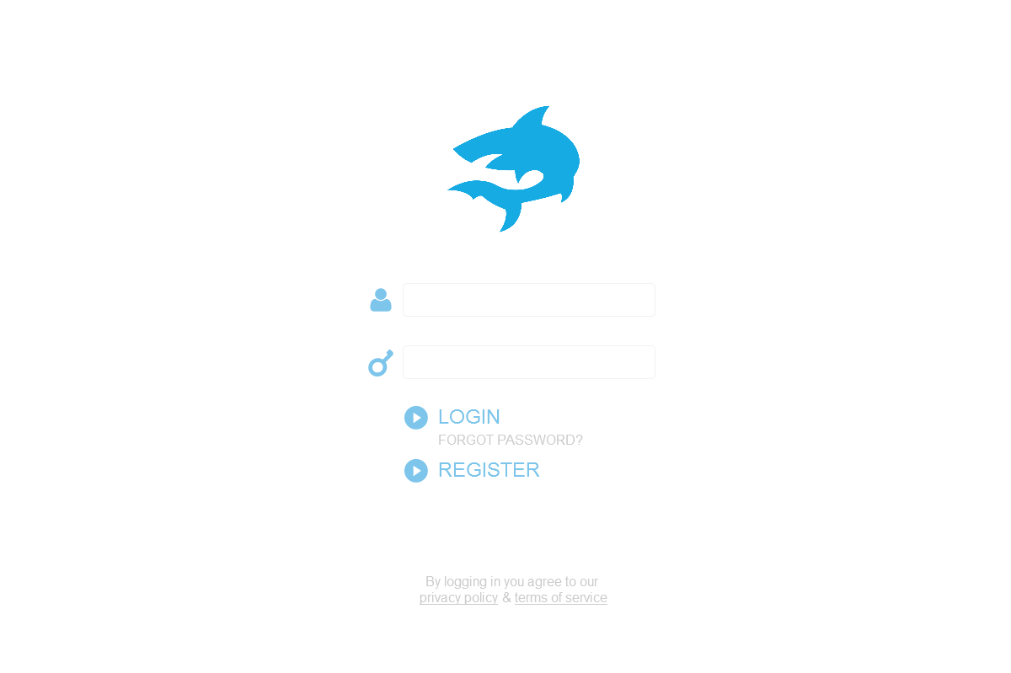**

**Description:**

Our Login/Registration page will be the index page to our website. In order to access our site you MUST BE REGISTERED, there is nothing about this site that should be public to people who are not employed.

**Stub-Calls:**

Register Function(s)

1.) Accepts Registration associative array:

a.) Package up all the information we need from our forms

into organized data to be inserted into our database to register a new

user

2.) Registration **Employee table** requires:

a.) Valid Employee First Name (Separate Function Validates)

b.) Valid Employee Last Name (Same Function Validates as First

Name)

c.) Valid Employee birthday (Separate Function Validates)

3.) Registration **Contact\_Information table** requires:

a.) Valid Phone Number (Separate Function Validates)

b.) Valid Email Address (Separate Function Validates)

c.) Valid Zip-Code (Separate Function Validates)

4.) Registration **Position table** requires:

a.) Valid Registration Code Generated by Admin

i.) That registration code will give access to position\_id

5.) Registration **Availability\_table** requires:

a.) Valid Days Available (Will be Options to Select, No Validation

Required)

b.) Valid START TIMES for each DAY AVAILABLE

1.) Accepts initial Associate array

2.) Calls Validation checks listed above on each index of associative array that needs validation

3.) Returns TRUE on a successful registration and adding a new Employee to our Database

**Bool Register (char RegisterInfo[]);**

1.) Accepts either first or last name

2.) Checks each character to ensure it is a valid character

3.) Checks length of string to ensure it’s less than or equal to 25

4.) Returns TRUE on Successful validation, FALSE on error

**Bool NameValidate(String name)**

1.) Accepts a Date (Users Birthday)

2.) Checks to make sure that the user’s age matches requirements for position

a.) Servers must be ATLEAST 18

b.) Bartenders must be ATLEAST 21

c.) All others must be ATLEAST 16

3.) return TRUE on Success, FALSE on Failure

**Bool BirthdayValidate(Date bday)**

1.) Accepts Phone Number

2.) Ensures the number of digits is EXACTLY 10

3.) Ensures all the values are digits

4.) return TRUE on Success, FALSE on Failure

**Bool PhonNumberValidate(double phoneNumber)**

1.) Accepts Email Address

2.) Ensures that the email has proper format

a.) Either lookup API for this

b.) Or check for “@” and “.com” to exists in the string

3.)Check to make sure email length is less than or equal to Max email length

4.) return TRUE on success, FALSE on failure

**Bool EmailValidiate(String emailAdress)**

1.)Accepts a Zipcode

2.)Checks to make sure zip code has 5 digits exactly

3.) returns TRUE on Success, FALSE on failure

**Bool ZipValidate(int zipcode)**

1.) A code is generated by our Manager that allows an employee to register AND links the employee to a position ID

2.) We check that the code to make sure it is accurate (Check against codes in Database)

3.) returns position ID if the code is valid, returns -1 if invalid code

**int ValidationCode()**

1.) Accepts email and password (both strings)

2.) Runs Query against database that receives the hashed password associated with the email

3.) We will hash the password that was inputted and compare it to the one from the Database

4.) On success, fill out all necessary Session Variables and allow login, return true

5.) On failure, return false

**Bool Login(String email, String Password)**

**--EMPLOYEE HOME--**

**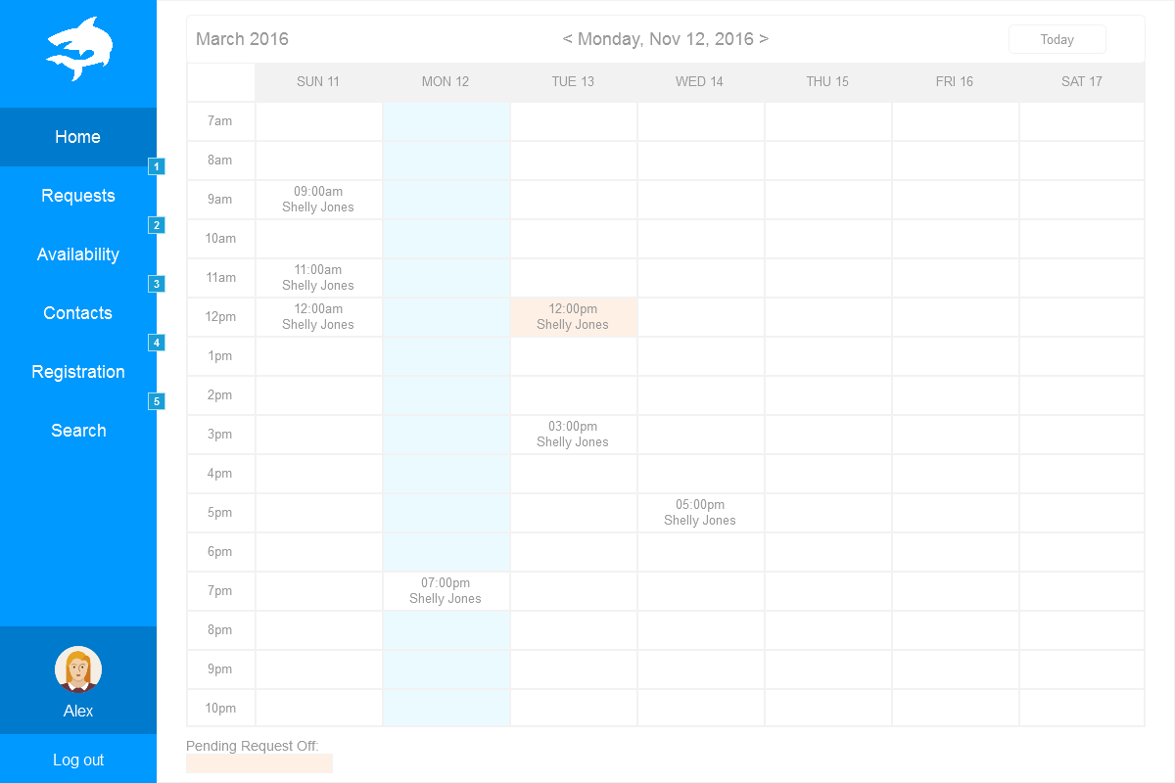**

**Description:**

Upon login, our users will be able to view their schedule as their home page. This allows for a quick login, check schedule, and logout.

**Stub-Calls:**

1.) Accepts nothing, returns nothing

2.) Runs a strategic query on our Schedule table to print the information out in an organized fashion viewable for the employee

**Void LoadSchedule()**

1.) Logout Accepts nothing, and returns nothing

2.) This function will remove all SESSION variables we currently have present

**Void Logout()**

**--EMPLOYEE AVAILABILITY--**

**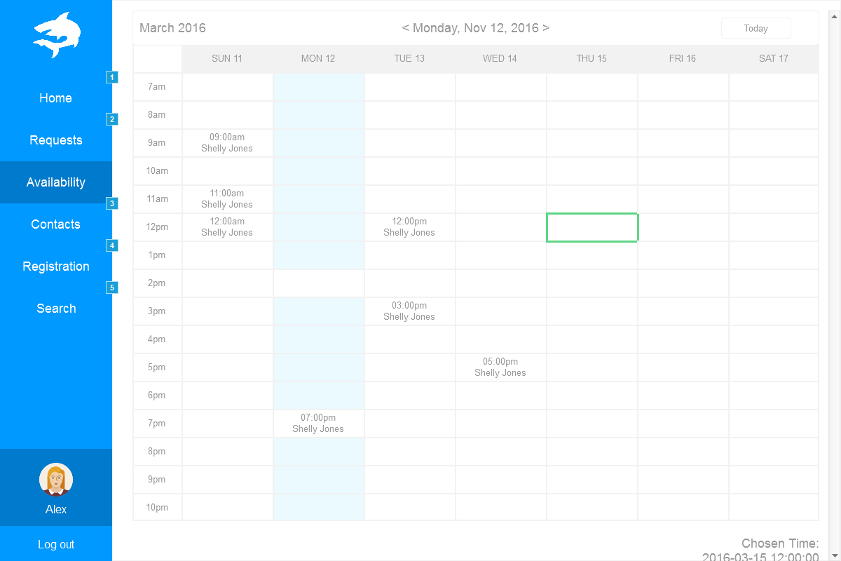**

**Description:**

This page will allow our users to update their availability (Upon approval by a manager). It will be a simple form to fill out that will be extremely similar to the form that we use to get availability during registration.

**Stub-Calls:**

1.) This will accept the information from the update availability form

2.) Insert this information into our Availability table (UNNAPROVED)

3.) The manager will have to approve availability before changes take effect

4.) Return TRUE on success, FALSE on failure

**Bool UpdateAvailibility()**

**--EMPLOYEE CONTACT--**

**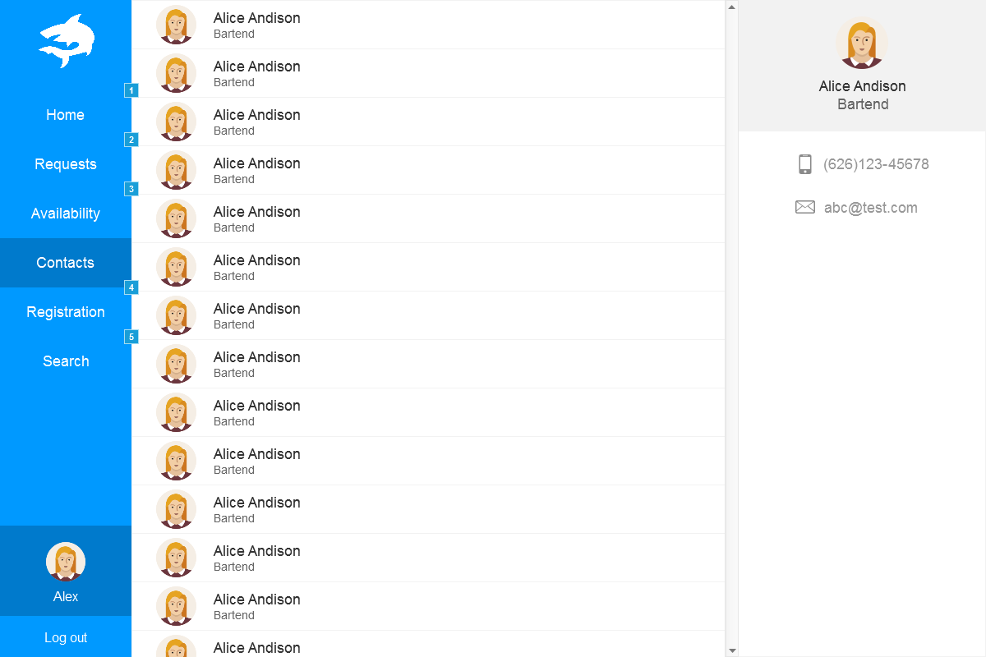**

**Description:**

This page will allow our users to check on contact information for other employees. The information given will be limited to employees of a similar position ID. There is no reason to contact other employees for non-professional purposes, therefor we will not be providing unnecessary information.

**Stub-Calls:**

1.) Accepts employees positionID (will be stored as a session variable for easy access)

2.) Displays the common PositionID contact information in a structured manor

**Void DisplayContactInfo(int positionID)**

**--EMPLOYEE REQUEST OFF--**

**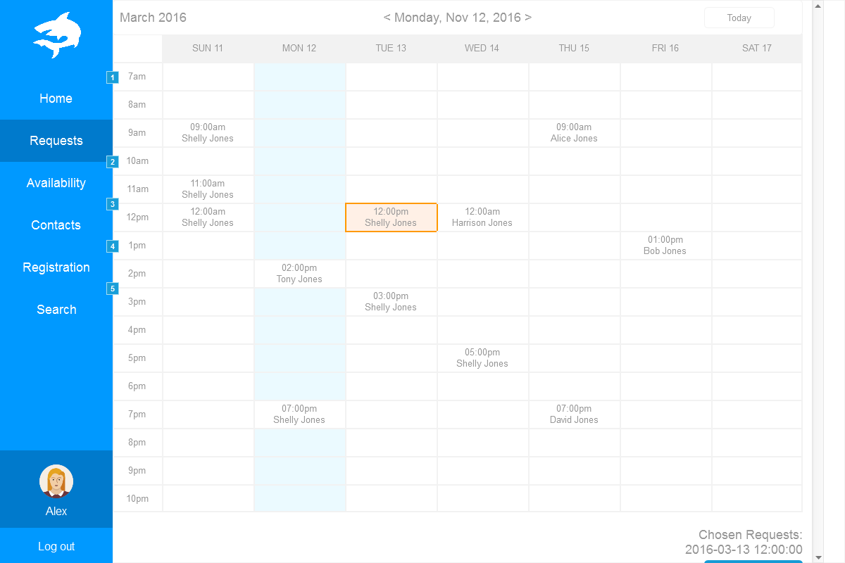**

**Description:**

This page will allow our users to submit request off requests. A simple form will be present to allow the user give us information on the start date, and the end date of their request off. A text box will also be available for the employee to give a description as to why they are requesting off.

**Stub-Calls:**

1.) Accepts an associative array that stores the information with regards to request off

2.) Does minor error checking on dates to ensure that date is in the future

3.) On success, request off is stored in the Database to be approved/denied by the

manager

**Bool submitRequestOff(String requestOffInfo[])**

**--MANAGER HOME--**

****

**Description:**

Upon login, our managers will be able to view the schedules for each type of employee in an organized manor.

**Stub-Calls:**

1.) Accepts positionID, returns nothing

2.) Runs a strategic query on our Schedule table to print the information out in an organized

fashion viewable for the manager (ALL SCHEDULES ARE PRINTED)

**Void LoadSchedule(int positionID)**

1.) Logout Accepts nothing, and returns nothing

2.) This function will remove all SESSION variables we currently have present

**--MANAGER AVAILABILITY--**

****

**Description:**

This page will allow our managers to approve/deny any pending changes to employees availability.

**Stub-Calls:**

1.) This function accepts the action (Approve or Deny) the employee ID to alter their

availability, and an array storing the new availability

2.) If action is Deny, then we remove this request from the table, and return

3.) On Accept, Update table and return

**Bool ManagerAvailability(String action, int employeeID, String availability[])**

**--MANAGER CONTACT--**

****

**Description:**

This page will allow our users to check on contact information for everyone. Managers will have the privilege to view ALL Employees contact information no matter what position they have.

**Stub-Calls:**

1.) Accepts employees positionID (will be stored as a session variable for easy access)

2.) Displays the common PositionID contact information in a structured manor

**Void DisplayContactInfo(int positionID)**

**--MANAGER REQUEST OFF--**

****

**Description:**

This page will allow our manager to approve or deny any request off

**Stub-Calls:**

1.) Accepts associative array with request off info and approve or deny

2.) Action is deny, we delete this request from our table

3.) Action is accept, we update information in Database to not allow that employee to // be scheduled during the time given.

**Bool ActionRequestOff(String info[], String action)**

TESTING

**-- USER ACCEPTANCE TESTING: (VERIFICATION) --**

This step of testing will take place once we have a physical user interface to interact with. For this portion, we request that you take a look at the general sketches and description of each page and give us feedback on the general design. Following our User Requirements (ABOVE IN THIS DOCMENT), we feel we have successfully addressed every one of our requirements. This design will enable us to allow for login and registration, ability to give availability, ability to request off, and update any personal information that the user gives us during the registration process. We will address User Acceptance testing in much greater detail as we begin to develop the physical UI.

**-- UNIT TESTING: (PLENTY MORE TO COME AS WE GET FURTHER ALONG) (VALIDATION) --**

1. Test to ensure registration form Data successfully is stored into our Database
2. Test to ensure that the availability can be updated by a user, viewed by a manger, and approved and stored back as the default availability for the user who requested the update
3. Test to ensure SERVERS can only view SERVER and MANAGER contact information (not able to view other employee’s info)
4. Test to ensure there are NO SQL INJECTION Vulnerabilities
5. Test to ensure we can successfully run an array of queries on our Database (General Search page) and return valid results
   1. NO SQL INJECTIONS
   2. PREPARED STATEMENTS
6. Test to ensure the Schedule is filled out completely

**-- REGRESSION TESTING: (VALIDATION) --**

Regression testing will occur with each step we complete from this point on. We have now successfully deployed our Database, and within the next week we will be building our web interface to interact with users and store vital information necessary to generate schedules for our employees. Every piece of information we collect, whether it is at the registration phase or updated information later on (example: updating availability) we will be ensuring that with every functional piece we add to our web application, we will check our database to ensure no data was stored improperly. If every step allows our data to remain useful, our scheduling algorithm will work just fine.

**--INTEGRATION TESTING: (VALIDATION)--**

We are creating a LAMP stack in order to run our application:

1. We have started by creating a LINUX virtual machine
2. Next, we integrated an APACHE WEB SERVER onto our VM
3. Next, we integrated MYSQL Database that we are using on our APACHE WEB SERVER
4. Finally, we have integrated PHP in order to communicate between our WEB SERVER (Client) and our MYSQL DATABASE (Server)

We will be testing with every piece of our UI that we create that we don’t break anything that already is working. If we find a bug, we will revert and start from scratch on the current problem we are trying to solve.

Change Log

|  |  |  |  |
| --- | --- | --- | --- |
| # | Date | By | Description |
| 01 | 03/10/2016 | All | Sprint one meeting: decide how tasks are divvied up |
| 02 | 03/15/2016 | Kaitlin Anderson &  Jeremy Warden | Create user requirements |
| 03 | 03/15/2016 | Jeremy Warden &  Kaitlin Anderson | Create system requirements |
| 04 | 03/15/2016 | Josh Lewis &  Han Chen | Create functional requirements |
| 05 | 03/15/2016 | Han Chen &  Josh Lewis | Create non-functional requirements |
| 06 | 03/15/2016 | Jeremy Warden | Cerate DDL, User Case |
| 07 | 03/15/2016 | Kaitlin Anderson | Create ERD |
| 08 | 03/17/2016 | Josh Lewis | Integrate the documents and diagrams, create table of contents |
| 09 | 03/17/2016 | Han Chen | Create change log and glossary |
| 10 | 3/27/2016 | Jeremy Warden | **Finalized**: ERD, DDL, UI  **Updated**: Table of contents, Glossary, Testing Scenarios. (SPRINT 1) |
| 11 | 4/10/2016 | Kaitlin Anderson | Update Requirements Analysis Document |
| 12 | 4/10/2016 | Joshua Lewis | Create DML (SPRINT 2) |
| 13 | 4/10/2016 | Han Chen | Create UI (SPRINT 2) |
| 14 | 4/10/2016 | Jeremy Warden | Create stub calls (SPRINT 2) |
| 15 | 4/10/2016 | Jeremy Warden | Updated UI portion in document |
| 16 | 4/10/2016 | Kaitlin Anderson | Documentation of Sprint 2 |

GLOSSARY

**Schedule**

A list of employees, and associated information, for example, position, working time, responsibilities for a given time period.

**User Requirements**

What the users expect the software to be able to do. The user requirements can be used as a guide to planning cost, timetables, milestones, testing, etc.

**System Requirements**

In order to work efficiently, all computer software needs certain hardware components or other software resources to be present on a computer. These prerequisites are known as system requirements and are often used as a guideline as opposed to an absolute rule.

**Functional Requirements**

It essentially specifies what the system should do. It specifies a behavior or function, for example, display the name, available time and edit the employees’ information, etc.

**Non-functional Requirements**

It essentially specifies how the system should behave and that it is a constraint upon the systems behavior. One could also think of non-functional requirements as quality attributes for of a system.

**Entity Relationship Diagram (ERD)**

Dealing with scheduling, involves a lot of data. We use this ERD diagram in order to give a pictorial representation of how our data will be stored. ERD’s use relationships between the data in order to store it more accurately and more clean.

**Data Definition Language (DDL)**

We take the ERD diagram and create a series of CREATE TABLE statements in SQL that allow our design to come to life on our Linux Virtual Machine.

**User Interface (UI)**

It is essential to the process that we show a rough draft of interface that our user will visually see. This allows us to get your approval on the scheme and also discuss within our group what layout will be the most effective for our application.

**LAMP Stack**

Includes the four open-source components: the Linux operating system, the Apache HTTP Server, the MySQL relational database management system (RDBMS), and the PHP programming language.